

Week 3 · Task 7

Footprinting & OSINT (Passive Reconnaissance)

Submitted By
Ali Hamza

Registration No
TBS-2026-017

Course
Ethical Hacking Internship

Organization
TechBizz Security

Submission Date
16 July 2026

Table of Content

1. Introduction to Passive Reconnaissance
1.1 Definition of Passive Reconnaissance
1.2 Importance in Ethical Hacking
1.3 Difference Between Passive and Active Reconnaissance
1.4 OSINT (Open-Source Intelligence) Overview

2. TryHackMe Resources

2.1 TryHackMe — Passive Reconnaissance Room
2.1.1 Introduction to Passive Reconnaissance
2.1.2 Information Gathering Techniques
2.1.3 WHOIS Lookup
2.1.4 DNS Information Gathering
2.1.5 Searching Public Information
2.1.6 Email and Subdomain Discovery
2.1.7 OSINT Tools Overview

2.2 TryHackMe — Google Dorking Room
2.2.1 Introduction to Google Dorking
2.2.2 Search Engine Reconnaissance
2.2.3 Google Search Operators
2.2.4 Site Operator (site:)
2.2.5 File Type Operator (filetype:)
2.2.6 URL Search Operator (inurl:)
2.2.7 Finding Publicly Exposed Information
2.2.8 Google Dorking in Ethical Hacking

3. Practical Tasks Performed

3.1 WHOIS Domain Information Gathering
3.1.1 WHOIS Command Usage
3.1.2 Domain Registration Details
3.1.3 Registrar Information
3.1.4 Registrant Information Analysis
3.1.5 Name Server Identification

3.2 Google Dorking Practical Exercises
3.2.1 Testing Site Search Queries
3.2.2 Searching Specific File Types
3.2.3 Finding Login Pages Using Search Operators
3.2.4 Recording Search Results

3.3 theHarvester OSINT Tool
3.3.1 Introduction to theHarvester
3.3.2 Installing and Configuring the Tool
3.3.3 Domain-Based Information Gathering
3.3.4 Email Discovery
3.3.5 Subdomain and Host Discovery
3.3.6 Analyzing the Results

4. YouTube Learning Resources

4.1 Passive Reconnaissance OSINT Tutorial for Beginners
4.1.1 Introduction to OSINT
4.1.2 Reconnaissance Methodology
4.1.3 Public Information Collection
4.1.4 Common OSINT Tools
4.1.5 Real-World Recon Examples

4.2 Google Dorking Tutorial for Beginners
4.2.1 Introduction to Google Dorks
4.2.2 Advanced Search Techniques
4.2.3 Search Operators Explained
4.2.4 Finding Exposed Information
4.2.5 Ethical Use of Google Dorking

5. Tools Used
5.1 Kali Linux
5.2 WHOIS
5.3 Google Search Engine
5.4 Google Dork Operators
5.5 theHarvester

6. Findings and Documentation
6.1 Recon Notes Preparation
6.2 Screenshot Documentation
6.3 Results Analysis
6.4 Lessons Learned

7. Conclusion
7.1 Summary of Passive Reconnaissance Activities
7.2 Importance of Information Gathering in Ethical Hacking
7.3 Future Learning Steps

Run whois <domain> on a public domain and read the registrant info.  Field | Value
Domain Name | GOOGLE.COM
Registrar | MarkMonitor Inc.
Registrant Organization | Google LLC
Registrant Country | US
Creation Date | 1997-09-15
Expiry Date | 2028-09-13 / 2028-09-14
Name Servers | ns1.google.com, ns2.google.com, ns3.google.com, ns4.google.com
DNSSEC | Unsigned

Registrant Information (Main Part)
The task specifically says:
Run whois <domain> on a public domain and read the registrant info.
Tumhare output mein:
- Registrant Organization: Google LLC
- Registrant Country: US
Task: Run WHOIS on a public domain and read the registrant information.
Command Used:
whois google.com
Observation:
- Domain Name: GOOGLE.COM
- Registrar: MarkMonitor Inc.
- Registrant Organization: Google LLC
- Registrant Country: US
- Creation Date: 15 September 1997
- Expiry Date: 13 September 2028
- Name Servers: ns1.google.com, ns2.google.com, ns3.google.com, ns4.google.com
]
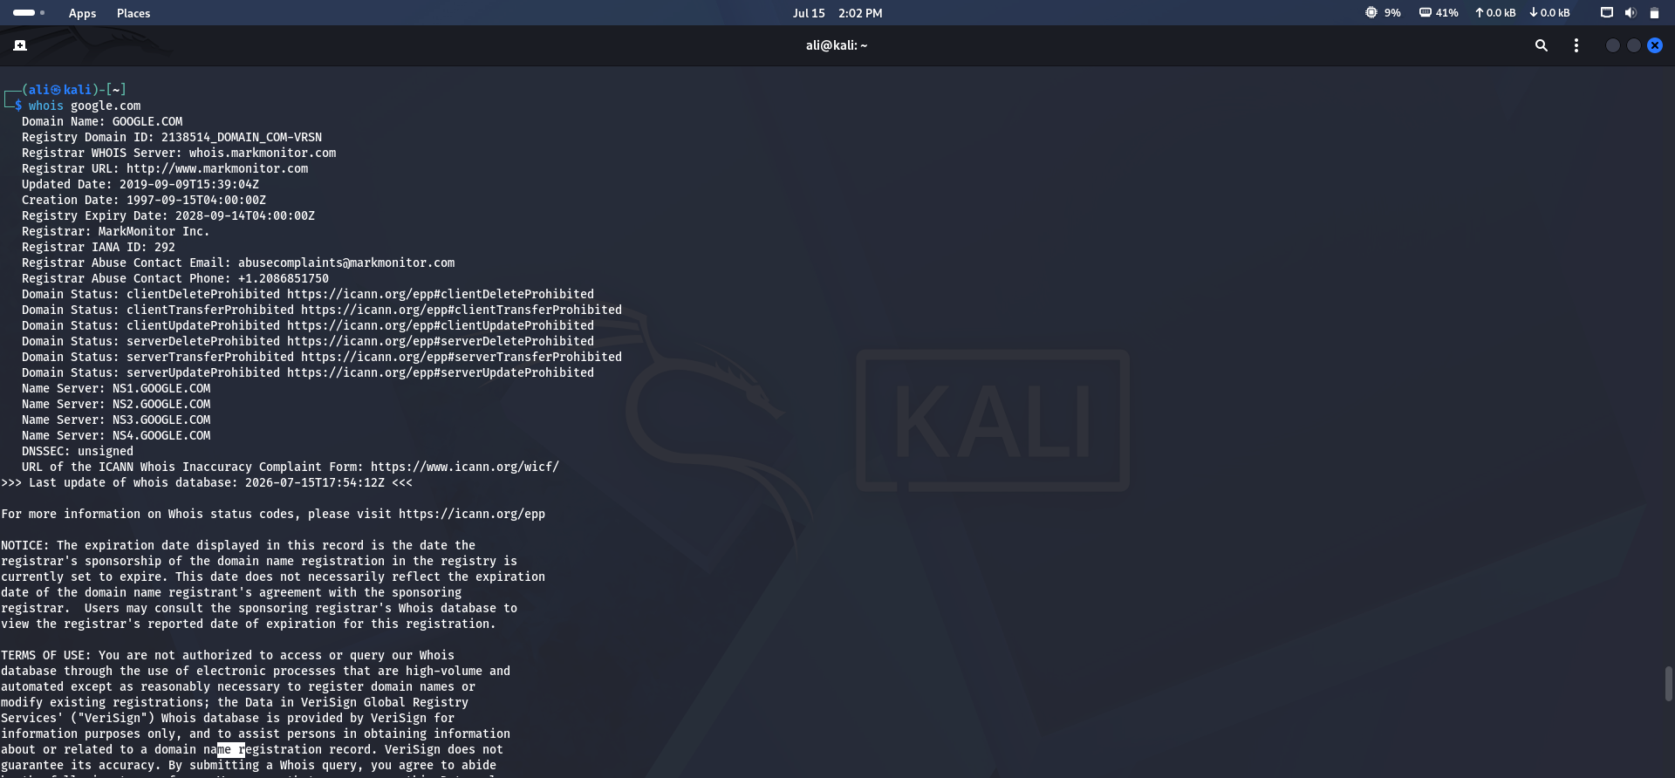
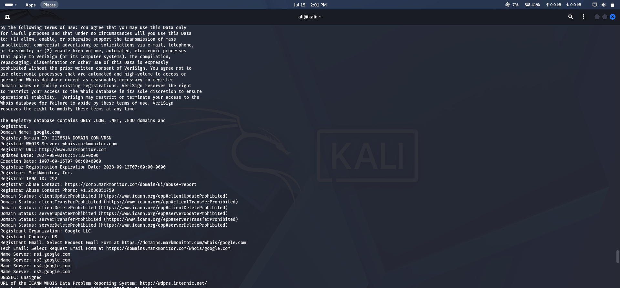

Try 3 Google Dorks.
Google Dorks Used:
- site:tryhackme.com cybersecurity
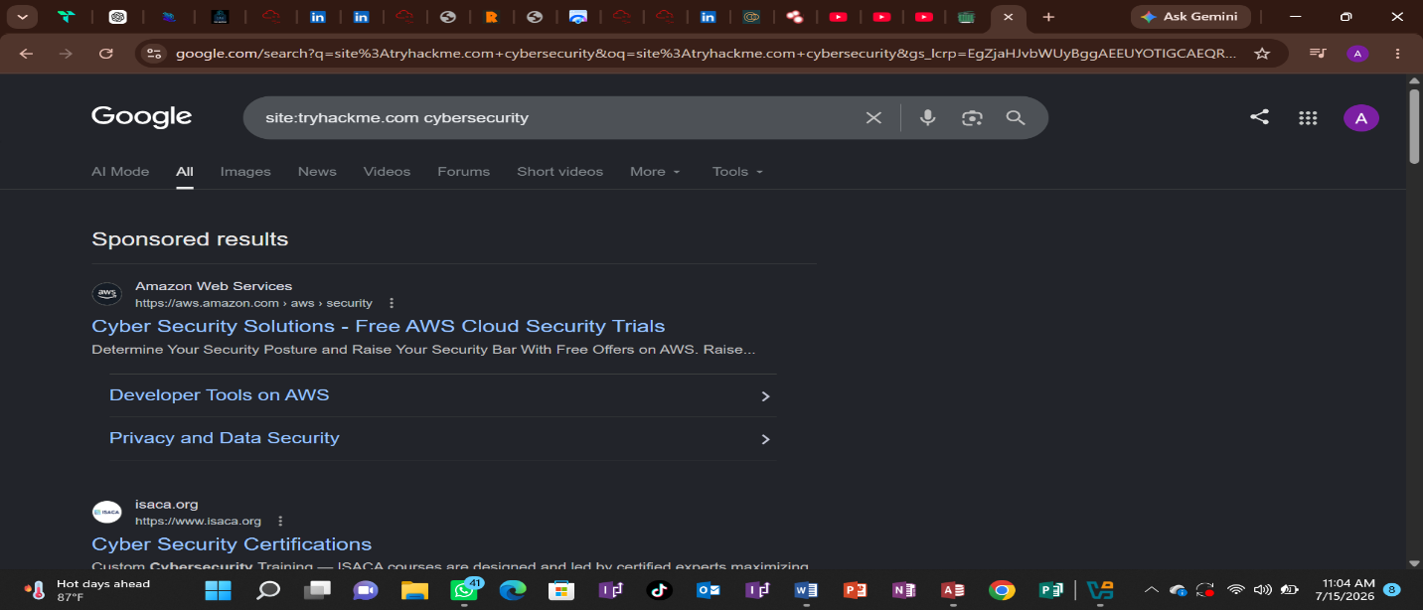
- filetype:pdf cybersecurity
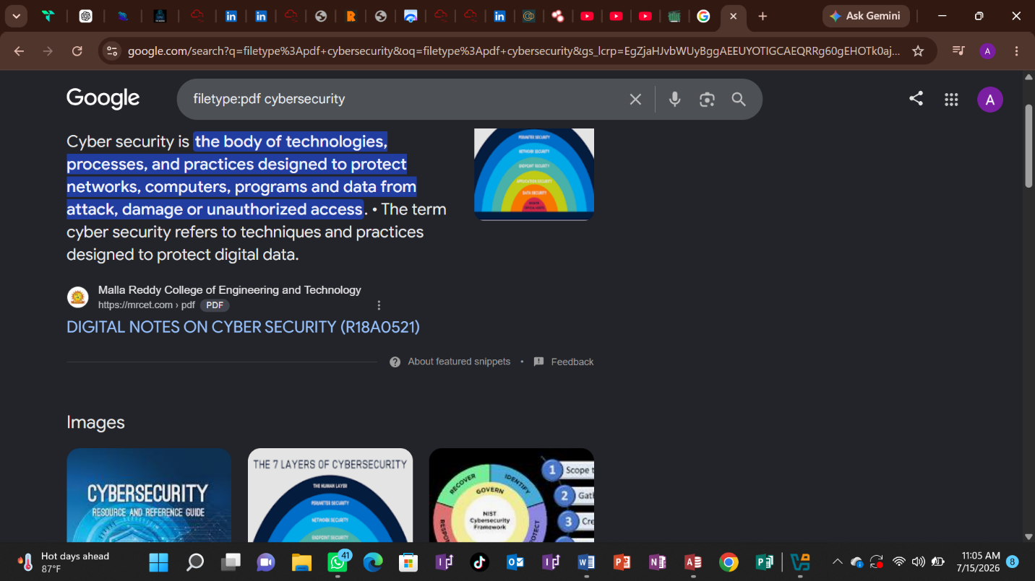
- :login inurl
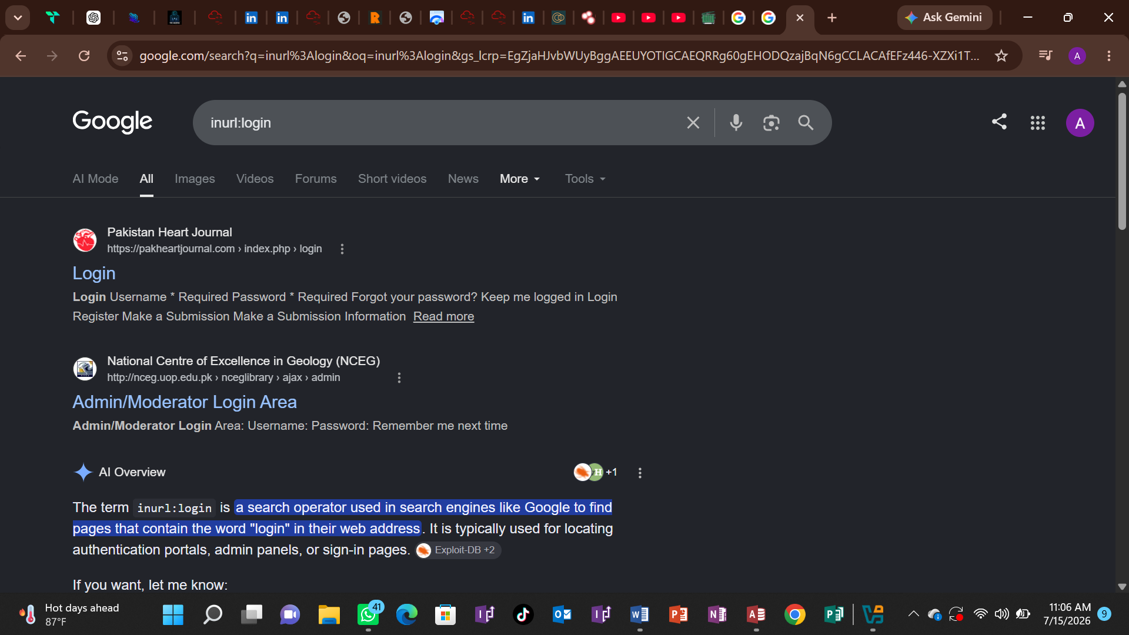
Observation:
- site: searches only within a specific website.
- filetype: finds documents of a specific format (such as PDF).
- inurl: searches for pages containing a specific keyword in the URL, such as login.

theHarvester Reconnaissance
theHarvester ek OSINT tool hai jo domain se related publicly available information collect karta hai, jaise:
- Email addresses
- Subdomains
- Hosts
- IP addresses

Tool Used
- theHarvester 4.11.1

Command Executed
theHarvester -d google.com -b all

Findings
Scan Result:
- Target Domain: google.com
- Source: CRTsh
- Emails Found: None
- Hosts Found: None
- IP Addresses Found: None
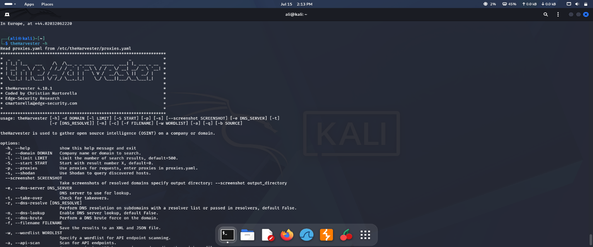
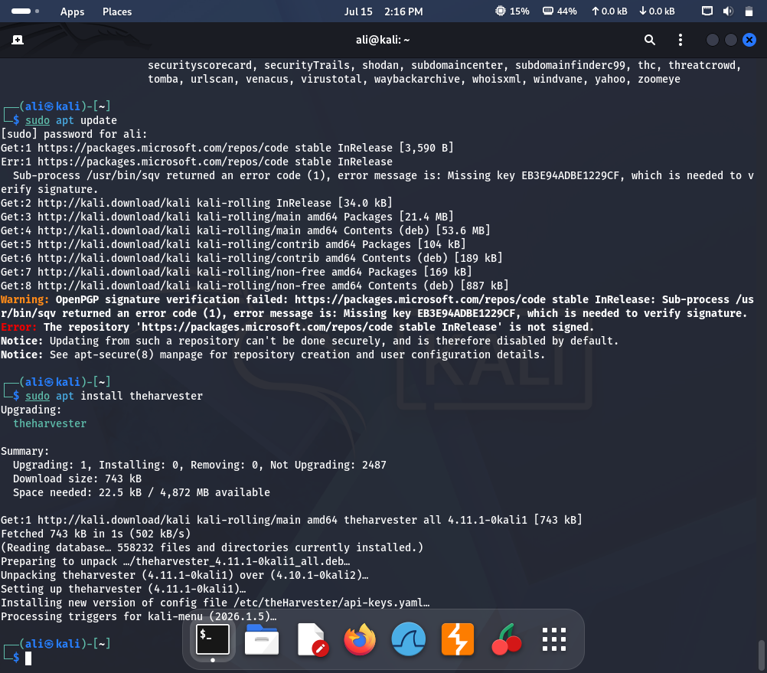
theHarvester -d google.com -b crtsh
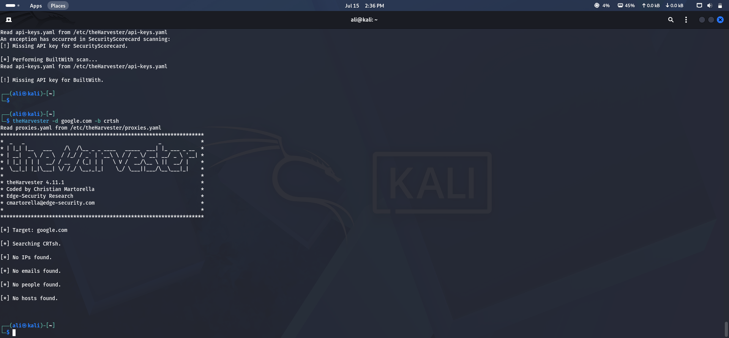

Recon Notes File Creation

Objective
To organize all collected reconnaissance findings into a structured notes file for documentation and future reference.

Description
A file named recon_notes.txt was created to store the findings collected during the passive reconnaissance phase. The file included important details such as WHOIS information, Google Dorking results, and theHarvester output.

Command Used
nano recon_notes.txt
The collected information was added to the file and saved for documentation purposes.

Result
The reconnaissance findings were successfully organized and stored in the recon notes file.

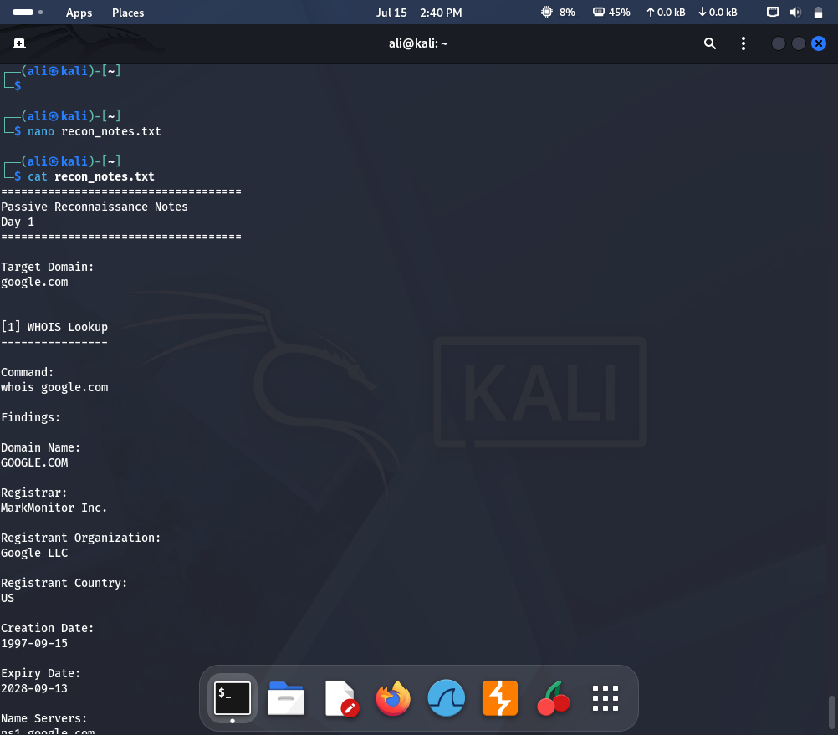

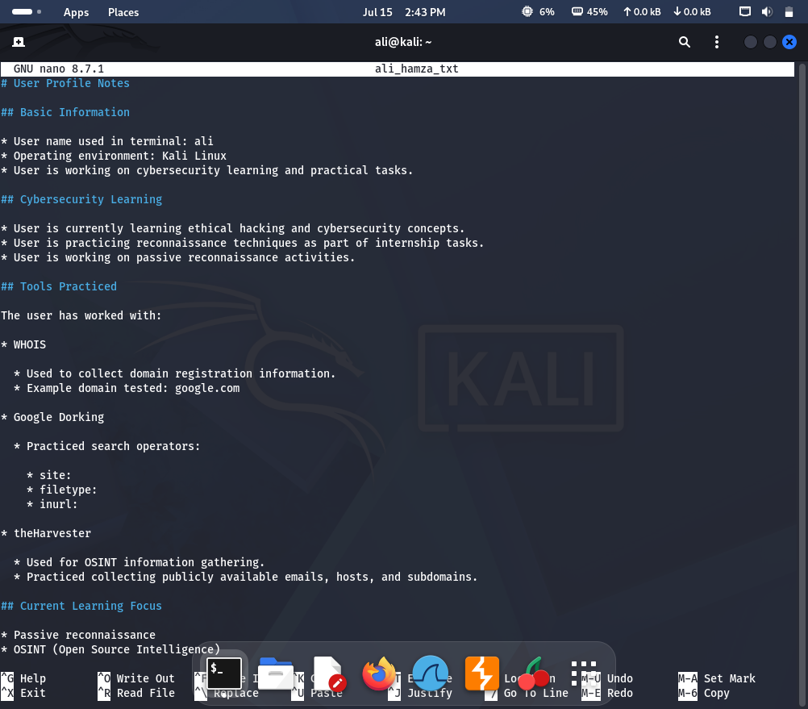

TryHackMe Resources

TryHackMe — Passive Reconnaissance (free room)

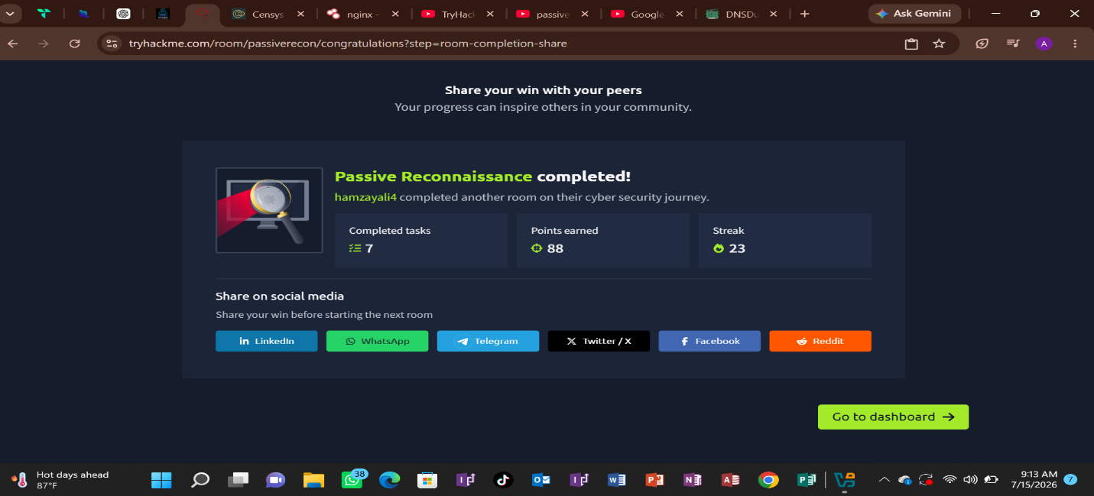

TryHackMe — Google Dorking (free room)

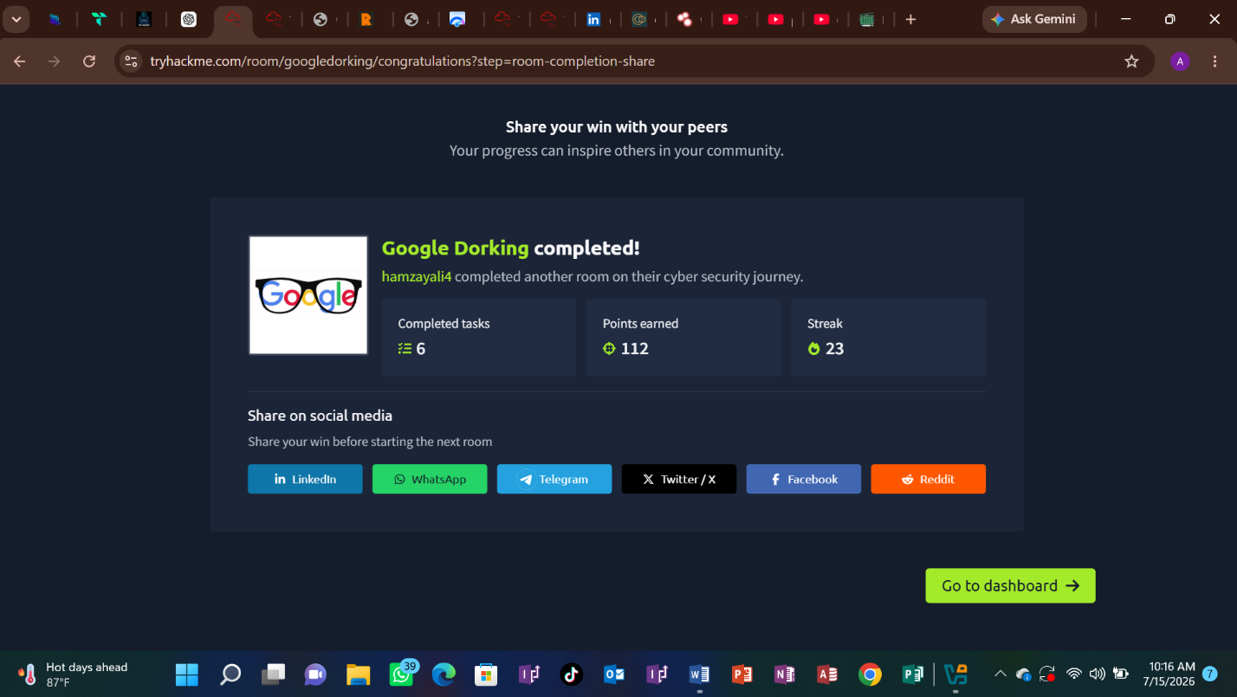

YouTube Learning Resources
Passive Reconnaissance OSINT tutorial videos
- OSINT of basic concept
- Real-world reconnaissance examples
- Information gathering techniques

Google Dorking beginner tutorials s
- Advanced Google searches
- Search operators use
- Publicly exposed information identify
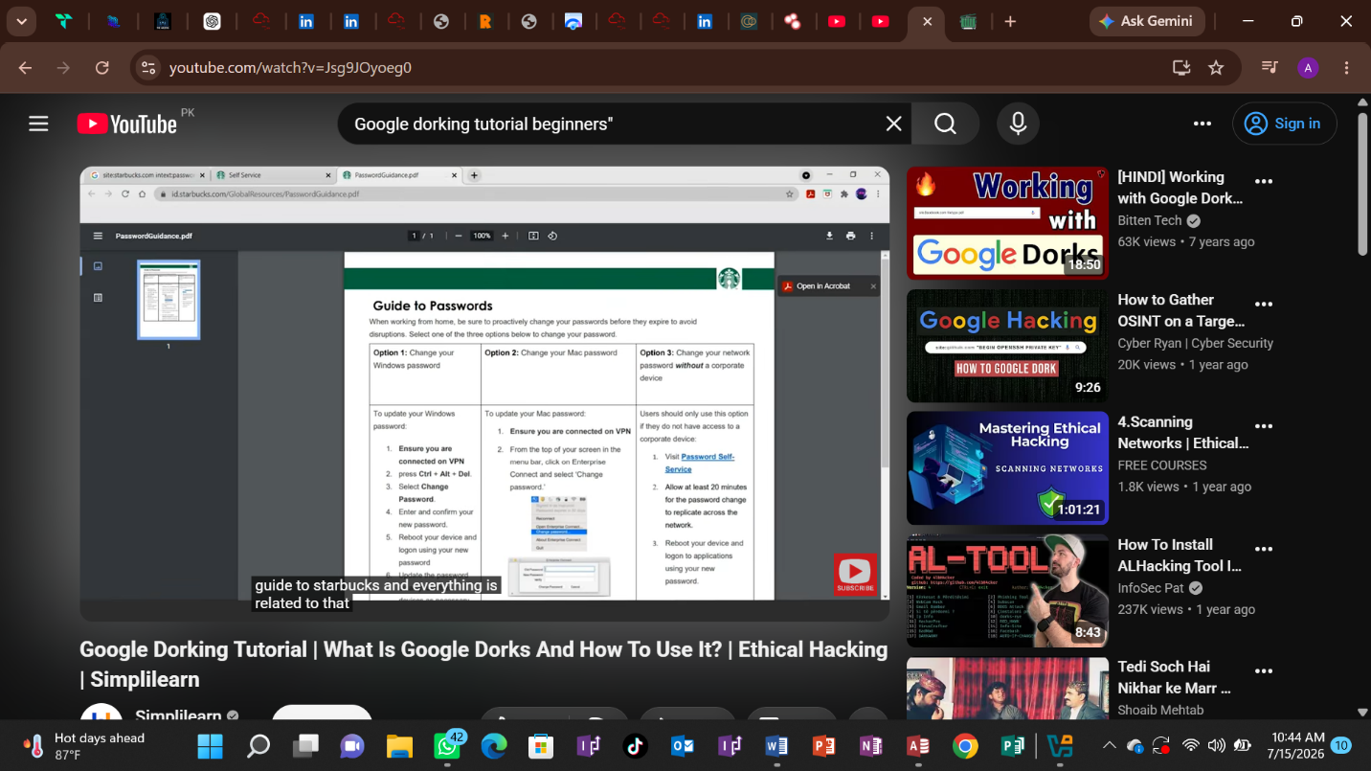

Conclusion
Day 1 mein passive reconnaissance aur OSINT techniques ka practical experience hasil kiya gaya. Is phase mein target systems ko directly touch kiye baghair publicly available information collect karna seekha gaya.
WHOIS lookup ke through domain registration details, registrar information, aur name servers identify kiye gaye. Google Dorking ke zariye advanced search operators ka use karke publicly available information discover karne ki practice ki gayi. theHarvester tool ke through domain se related emails, hosts aur subdomains collect karne ki koshish ki gayi.
In activities se ye samajh aya ke ethical hacking mein reconnaissance ek bohat important step hai kyun ke ye security professionals ko target ke digital footprint aur possible attack surface ko samajhne mein madad deta hai.
Passive reconnaissance techniques ka sahi use security testing ko efficient banata hai aur organizations ko apni publicly exposed information identify aur secure karne mein help karta hai.


